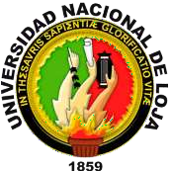

# NACIONAL UNIVERSITY OF LOJA

subject:

**English**

Names:

# Dennys Pucha

# Skarley Olmedo

# Andrea Sánchez

Loja-Ecuador

2023

Date: 01-08-2023 Group #1

